# Preparing General Mission Analysis Tool for Operational

# Maneuver Planning of the Advanced Composition

# Explorer Mission

Rizwan H. Qureshi[1] and Steven P. Hughes[2]

*NASA Goddard Space Flight Center, Greenbelt, MD, 20771, USA*

The General Mission Analysis Tool (GMAT) is an open-source space mission design, analysis and trajectory optimization tool. GMAT is developed by a team of NASA, private industry, public and private contributors. GMAT is designed to model, optimize and estimate spacecraft trajectories in flight regimes ranging from low Earth orbit to lunar applications, interplanetary trajectories and other deep space missions. GMAT has also been flight qualified to support operational maneuver planning for the Advanced Composition Explorer (ACE) mission. ACE was launched in August, 1997 and is orbiting the Sun-Earth L1 libration point. The primary science objective of ACE is to study the composition of both the solar wind and the galactic cosmic rays. Operational orbit determination, maneuver operations and product generation for ACE are conducted by NASA Goddard Space Flight Center (GSFC) Flight Dynamics Facility (FDF). This paper discusses the entire engineering lifecycle and major operational certification milestones that GMAT successfully completed to obtain operational certification for the ACE mission. Operational certification milestones such as gathering of the requirements for ACE operational maneuver planning, gap analysis, test plans and procedures development, system design, pre-shadow operations, training to FDF ACE maneuver planners, shadow operations, Test Readiness Review (TRR) and finally Operational Readiness Review (ORR) are discussed. These efforts have demonstrated that GMAT is flight quality software ready to support ACE mission operations in the FDF.

# Introduction

## NASA GSFC’s Navigation and Mission Design Branch (NMDB) is responsible for providing core expertise in navigation, trajectory design and mission analysis support for all missions at GSFC. The branch also provides on-orbit flight dynamics operations services through the FDF. As the operational arm of the NMDB, FDF’s operational services include orbit determination, acquisition and data generation for space and ground networks, tracking data evaluation and maneuver planning support. FDF has provided orbit maneuver services for unmanned NASA missions of nearly every kind of orbit including earth, lunar, libration point, and deep space. Typically the FDF supports flight dynamics computations for more than twenty missions. One such mission includes operational maneuver planning and support for the ACE mission. At present, the FDF conducts ACE mission’s maneuver planning and operational support using FreeFlyer. FreeFlyer is a commercial-off-the-shelf (COTS) trajectory design tool used for spacecraft mission analysis, design and operations.

The primary objective of this paper is to describe at a high level major operational certification milestones and entire engineering lifecycle that GMAT went through in order to be deemed operationally certified to support ACE maneuver operations in the FDF. In this work, core phases from operational certification cycle that we discuss are:

* Gathering of all the ACE operational maneuver support requirements levied on GMAT.
* Verification and validation of the levied requirements.
* Gap analysis that determined areas where GMAT could not meet levied requirements and required development of new ACE related features.
* Development, testing and documentation of new ACE related GMAT features.
* System design that explains how GMAT and other tools will be used to support ACE operations in the FDF.
* Pre-shadow operations phase in which GMAT scripts for ACE maneuver planning and product generation were written and output from GMAT was compared against FreeFlyer using several historical navigation solutions from Goddard Trajectory Determination System (GTDS).
* Development of test plans and procedures that the testers in FDF implemented to test and verify levied requirements on GMAT.
* Development of Local Operating Procedures (LOP) document that ACE maneuver planners use in the operations environment to support ACE operations using GMAT scripts.
* Training provided to the ACE maneuver planning team in how to utilize GMAT scripts to plan for and support ACE operations during a live Station-Keeping (SK) maneuver.
* Presentation of TRR to the Facility Review Board (FRB) to verify that all tools and environment are ready to support shadow operations during an ACE SK maneuver.
* Non-interfering shadow operations held in FDF in which ACE maneuver team used both GMAT and FreeFlyer to support a live ACE station-keeping (SK) maneuver and products from both tools were generated and compared against each other using latest Orbit Determination (OD) solution from GTDS.
* Presentation of ORR to the FRB to share results from test plans implementation and non-interfering shadow operations. At the end of ORR, GMAT was deemed an operationally certified maneuver planning tool in the FDF for the ACE mission.

The major focus of this effort was to demonstrate that GMAT is a mature, flight quality system that has been operationally certified to support real-time spacecraft mission operations. The work that we present is unique because prior to this effort, GMAT had never gone through an operational certification cycle in order to be deemed qualified to support mission operations in the FDF. In addition to being certified for ACE operations, this work has laid core groundwork for GMAT to target operational certification for other present and future Goddard missions. GMAT has been installed in FDF Mission Operations Room (MOR) and now in addition to FreeFlyer, GMAT is ready to be used as the primary maneuver planning tool to support ACE maneuver operations.

## ACE Mission Overview

ACE is a Sun-Earth libration point mission. The ACE mission is the third NASA spacecraft to fly a libration point orbit, and like International Sun-Earth Explorer 3 (ISEE-3) and Solar and Heliospheric Observatory (SOHO) before it, it orbits the Sun-Earth L1 point.**1** Launched on August 25, 1997, the ACE mission is to study the composition of both the solar wind and the galactic cosmic rays. ACE is a spin-stabilized spacecraft with a required spin rate of 5.0 ± 0.1 revolutions per minute (rpm). With a dry mass of 785 kg, ACE at launch had 195 kg of hydrazine fuel and a Δv capability of approximately 445 m/s.**2** As of mid-2013, ACE has 50.7 kg of fuel remaining. ACE is required at all times to have its spin axis (body +Z-axis) oriented such that the spin-axis-to-Sun angle is no fewer than 4 degrees and no more than 20 degrees. The ACE orbit is a Lissajous orbit of relatively small Rotating Libration Point (RLP) coordinate system X-axis and Y-axis amplitudes. Figure 1 shows the ACE mission orbit in the RLP coordinate system as seen from the North Ecliptic Pole (NEP). The RLP X-axis lies on the Sun to Earth-Moon Barycenter line, Y-axis points towards Earth’s motion and Z-axis is parallel to the NEP axis. The design amplitudes chosen for the ACE Lissajous were as follows: AX = 81,755 km, AY = 264,071 km, and AZ = 157,406 km.1 These amplitudes correspond to angular dimensions of approximately 6 degrees out-of-plane and 10 degrees in-plane (Y-axis).The natural evolution of the Lissajous orbit over its full 14-year cycle is shown in Figure 2.2

The basic philosophy for ACE Lissajous station-keeping is to coast for as long as can be tolerated in order to minimize operational impact to science. Although there was no hard specification on the upper size limit for station-keeping burns, it was decided based on SOHO experience that 0.75 m/s is a reasonable guideline.1 For ACE, there are two complicating factors to contend with regarding trajectory stability and maneuver design. First, the weekly spin-axis attitude reorientation maneuvers cause regular perturbations to the ACE Lissajous mission orbit. Second, the Lissajous Z-axis control maneuvers were required beginning about two years into the mission.1,3 The station-keeping maneuvers are typically three months apart but they can vary by a matter of weeks in either way. As of 23 September 2013, there have been 67 ACE station-keeping maneuvers starting from 15 January 1998 with nominal delta-v’s averaging 0.20 m/s and average intervals between burns of 103 days.

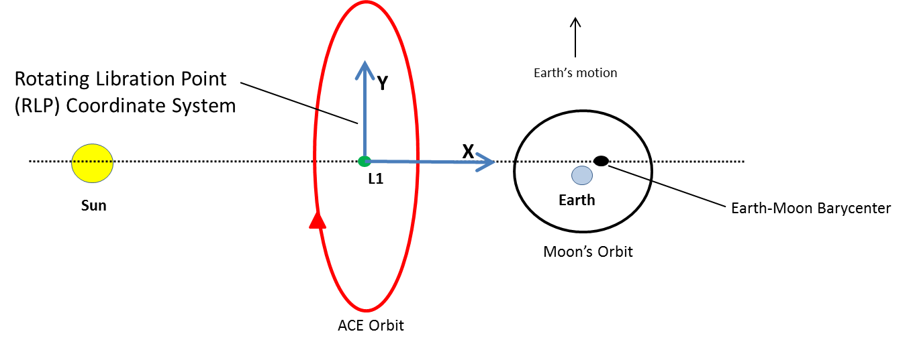

Figure 1: ACE mission orbit in Rotating Libration Point Coordinate System

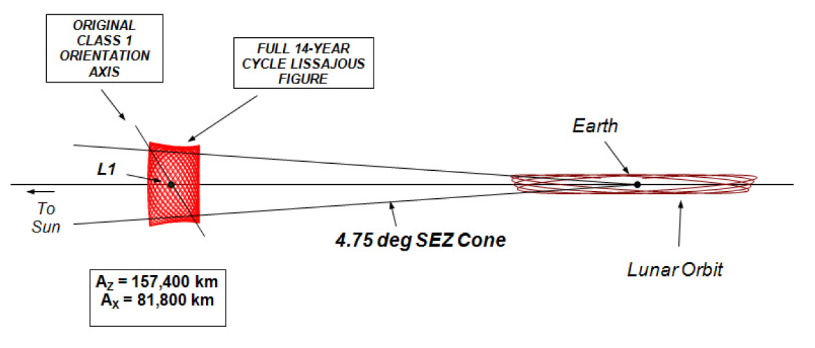

Figure 2: Evolution of ACE Lissajous Orbit 2

## GMAT Overview

The NMDB creates and maintains state-of-the-art analysis tools for mission design, trajectory optimization and navigation support. One such tool is GMAT. GMAT is a desktop mission design, analysis and trajectory optimization tool developed collaboratively by NMDB and the private sector. GMAT runs primarily on Windows (Mac and Linux are alpha) and can be run via script files or a full featured Graphics User Interface (GUI). GMAT is a high fidelity system designed to support nearly all flight regimes utilized for NASA missions including LEO, GEO, HEO, Lunar, and deep space missions. GMAT is written in C++ and is currently about 580k (400k non-comment) source lines of code.4, 5 The system has been used to optimize trajectories and maneuvers for the Lunar Crater Observation and Sensing Satellite (LCROSS), the Acceleration, Reconnection, Turbulence, and Electrodynamics of the Moon's Interaction with the Sun (ARTEMIS) missions, the Lunar Reconnaissance Orbiter (LRO), and was used for formation design and analysis for the Magnetospheric Multiscale Mission (MMS).

Two versions of GMAT were released in 2013. The GMAT R2013a version was released in April, 2013. The GMAT R2013a version is the first public release since May 23, 2012, the sixth public release and is the first major non-beta production release. GMAT R2013b was released in August, 2013. GMAT R2013b was a certification candidate to plan for and support ACE maneuver operations in the FDF. GMAT R2013b fully meets all of the requirements for ACE operational maneuver planning and product generation. The requirements for ACE operational maneuver planning were levied on the system by FDF’s ACE maneuver planners. The GMAT R2013b system has been certified for operational use for maneuver planning of the ACE mission by FDF’s FRB.

## ACE Operations Overview

The FDF provides operational orbit determination, station-keeping maneuver planning and product generation for the ACE mission. Several tools are used in the workflow to support ACE operations. ACE mission operations are conducted with tools that have been developed inside Goddard as well as with private COTS tools. Orbit determination is performed using GTDS tool. Impulsive maneuver targeting, trajectory propagation and product generation is performed using FreeFlyer. Attitude and finite-burn modeling is performed using Goddard’s General Maneuver Program (GMAN) tool.

Due to the frequency of weekly attitude maneuvers and the resulting orbital perturbations, maneuver planning and prediction for ACE is an ongoing process. Using FreeFlyer, the ACE maneuver team monitors the orbital evolution by performing impulsive maneuver targeting as OD updates are made available from GTDS via the TCOPS Vector Hold File (TVHF). Impulsive maneuver retargeting is performed via FreeFlyer to evaluate the efficiency of the last maneuver and to predict the time and magnitude of the next station-keeping maneuver. ACE maneuvers occur on the order of once every three months but there is significant variability. About two weeks prior to a maneuver, FDF begins finite maneuver planning using the impulsive maneuver delta-v approximation targeted in FreeFlyer from the most recent navigation solution provided from GTDS in a TVHF file. Several cycles of finite-burn planning and targeting occur depending on the frequency of propulsion and OD updates and the frequency of attitude, momentum management, and/or spin maneuvers.

Figure 3 shows the tools and workflow for current ACE maneuver operations in the FDF. Using FreeFlyer, initial impulsive maneuver targeting is performed in an ACE engineering coordinate system. FreeFlyer generates impulsive delta-v data and a Code 500 ephemeris. This Code 500 ephemeris is a binary ephemeris file that contains ACE maneuver epoch and corresponding state. Impulsive delta-V data and ACE maneuver epoch from Code 500 ephemeris is read by GMAN. Attitude modeling for ACE is then performed using GMAN. After selection of final attitude parameters has been manually entered into FreeFlyer from GMAN, then final impulsive maneuver is re-targeted in FreeFlyer using a spacecraft-attitude based delta-V coordinate system. Once FreeFlyer performs final impulsive targeting, then FreeFlyer is also used to generate a 28 days long ACE ephemeris. This 28 days long ACE ephemeris is the primary product that is delivered to the National Oceanic and Atmospheric Administration (NOAA) by the ACE maneuver planning team. Final finite-burn planning and command generation is performed by GMAN during the maneuver pass and the maneuver command file is generated using GMAN. Finally this maneuver command file is sent to Mission Operations Center (MOC). The MOC uploads this maneuver command file to the spacecraft. Notice that in Figure 3, FreeFlyer is the primary maneuver planning and product generation tool used for impulsive maneuver delta-v computations and for NOAA product generation.

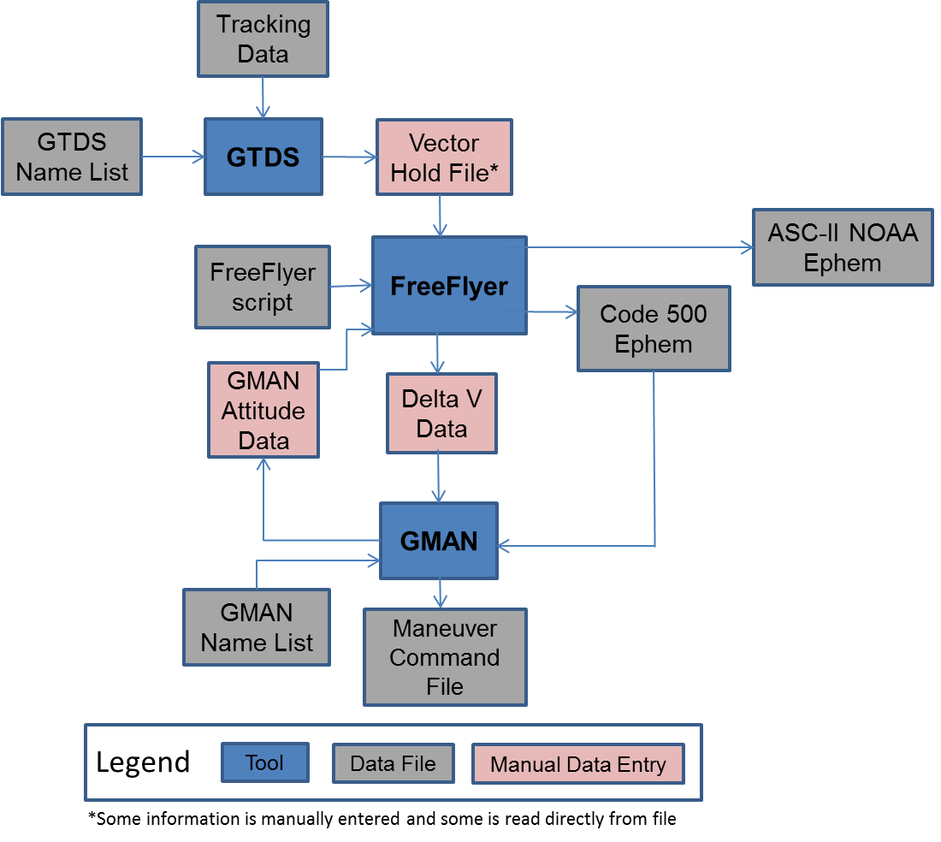

**Figure 3: Tools and Workflow for ACE Maneuver planning using FreeFlyer**

# Major Operational Certification Milestones

## Requirements Gathering

The FDF is responsible for compiling mission operations requirements for any tool that may be used to plan for and support any mission in an operational environment. The requirements for operational maneuver planning and support for the ACE mission were gathered by working closely with the ACE maneuver planning team which is located in the FDF. A total of 97 requirements were levied on GMAT to support and plan for ACE maneuver operations and product generation. Throughout the requirements gathering phase, one of the most important tasks was to analyze that the requirements that were levied on GMAT were clearly defined and any unnecessary requirements that do not reflect current ACE operations be removed.

Several draft versions of ACE requirements were exchanged between the ACE maneuver planning and GMAT team. After approximately 3.5 months of intense reviews, proper clarification and internal validation of all requirements, a final set of requirements was agreed upon between the ACE maneuver planning and the GMAT team. The final list of requirements went through a System Requirements Review (SRR) that was conducted by the FDF’s FRB. A complete list of requirements for ACE maneuver planning is shown in the Appendix section. Appendix 1 shows the ACE Requirements Traceability Matrix that lists all 97 requirements in a matrix form.6 The 97 requirements levied on GMAT were sub-divided into six requirements areas or categories. Table 1 shows the six requirements areas and total number of requirements that pertained to each requirements area. The six requirements areas were coordinate system, force model, maneuver targeting, orbit propagation, product output and spacecraft modeling.

**Table 1: Six Requirements Areas for ACE maneuver planning and support**

|  |  |
| --- | --- |
| ACE Requirements Areas | # of Requirements in  each Requirements Area |
| Coordinate System | 13 |
| Force Model | 15 |
| Maneuver Targeting | 27 |
| Orbit Propagation | 10 |
| Product Output | 22 |
| Spacecraft Model | 10 |

## Gaps Analysis

Once all the requirements for ACE maneuver planning and support were finalized, we analyzed all requirements to determine specific areas where GMAT could not meet the levied requirements. This process was called gaps analysis. Through the gaps analysis, we determined that GMAT was missing the following four major features that are listed below:

1. GMAT could not parse through a TVHF data file and automatically load spacecraft state and physical properties data directly from the data file.
2. GMAT could not generate an ephemeris in both the UNIX and PC versions of GSFC’s Code 500 binary format.
3. GMAT needed a new ACE coordinate system to target impulsive maneuvers. Please consult REQID # CS04 in Appendix 1 for full description of this new ACE Coordinate System.
4. GMAT could not report force model dependent parameters such as spacecraft acceleration vector components and acceleration magnitude.

This gaps analysis paved the way for GMAT software developers to begin development of these four new features. After the development of the features, these features were vigorously tested and later released with GMAT version R2013b in August 2013. GMAT R2013b is an internal-only release and now supports all features that are necessary to successfully plan for and support ACE maneuver operations in the FDF. Figure 4 shows GUI screenshots of the features and new script commands that were developed to support ACE mission operations. A brief summary of the newly developed features and script commands is discussed below. Please consult GMAT 2013b Release Notes section of the GMAT 2013b Users Guide document to get full details on the new features and improvements that have been developed in GMAT R2013b release.7

**Data File Interface:**

GMAT can now load a spacecraft state and physical properties data directly from a vector hold file. A new resource, FileInterface, controls the interface to the data file, and the new Set command lets you apply the data as part of the Mission Sequence. Figure 4 shows the GUI set-up for Data File Interface.

**Code-500 Ephemeris Format:**

GMAT’s EphemerisFile resource can now write a Code-500 format ephemeris file. The Code-500 format is a binary ephemeris format defined by FDF and can be written in either PC or UNIX versions. Figure 4 shows the GUI set-up of Code-500 ephemeris in EphemerisFile resource panel.

**New Local Aligned-Constrained Coordinate System:**

A local aligned-constrained coordinate system is one defined by an alignment vector and two constraint vectors. This is a highly flexible coordinate system that can be defined in many ways, depending on mission needs. Figure 4 shows the GUI set-up of local aligned-constrained coordinate system.

**Force Model Parameters:**

Users can now access force model dependent parameters, such as spacecraft acceleration vector components or acceleration magnitude. Figure 4 shows script snippet used to report spacecraft acceleration vector components and magnitude.

**FileInterface resource and Set command**

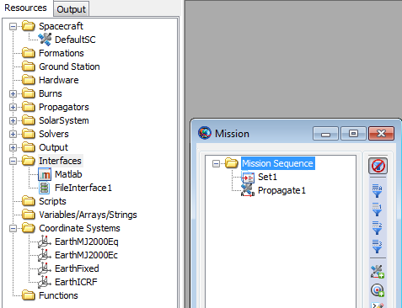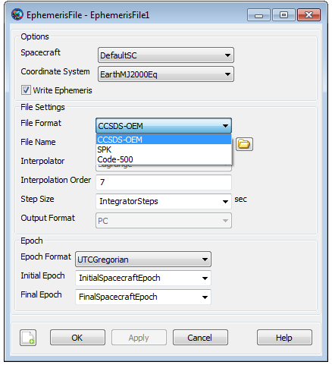

**Code 500 ephemeris Format**

**LocalAlignedConstrained Coord. Axis Type**

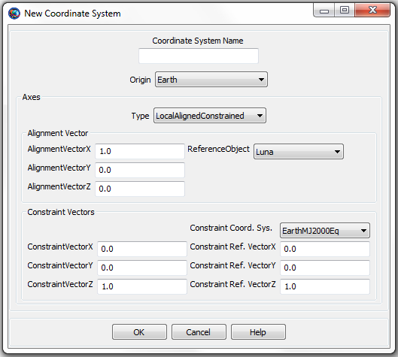

**Spacecraft acceleration parameters**

*Spacecraft.ForceModel.Acceleration*

*Spacecraft.ForceModel.AccelerationX*

*Spacecraft.ForceModel.AccelerationY*

*Spacecraft.ForceModel.AccelerationZ*

**Figure 4: New ACE related features developed in GMAT R2013b to support ACE Operations**

## System Design

After internal release of GMAT R2013b version, we re-designed the ACE maneuver operations tools and workflow block diagram that now shows GMAT being the primary maneuver planning tool along with all external tools required to completely support ACE maneuver operations in the FDF. Figure 5 shows ACE maneuver planning tools and workflow diagram with GMAT now being the central maneuver planning and trajectory propagation tool. In Figure 5, the tools are shown in blue, data files that are exchanged between tools are shown in gray and places where there is manual data entry into the tools is shown in pink. Notice that the tools and workflow block diagram shown in Figure 5 is very similar to the tools and workflow diagram in Figure 3 except with one major exception: In Figure 5, instead of FreeFlyer, now GMAT is the primary maneuver planning tool that can be used to compute impulsive ACE station-keeping delta-v and generate code 500 and 28 days long NOAA ephemeris products.

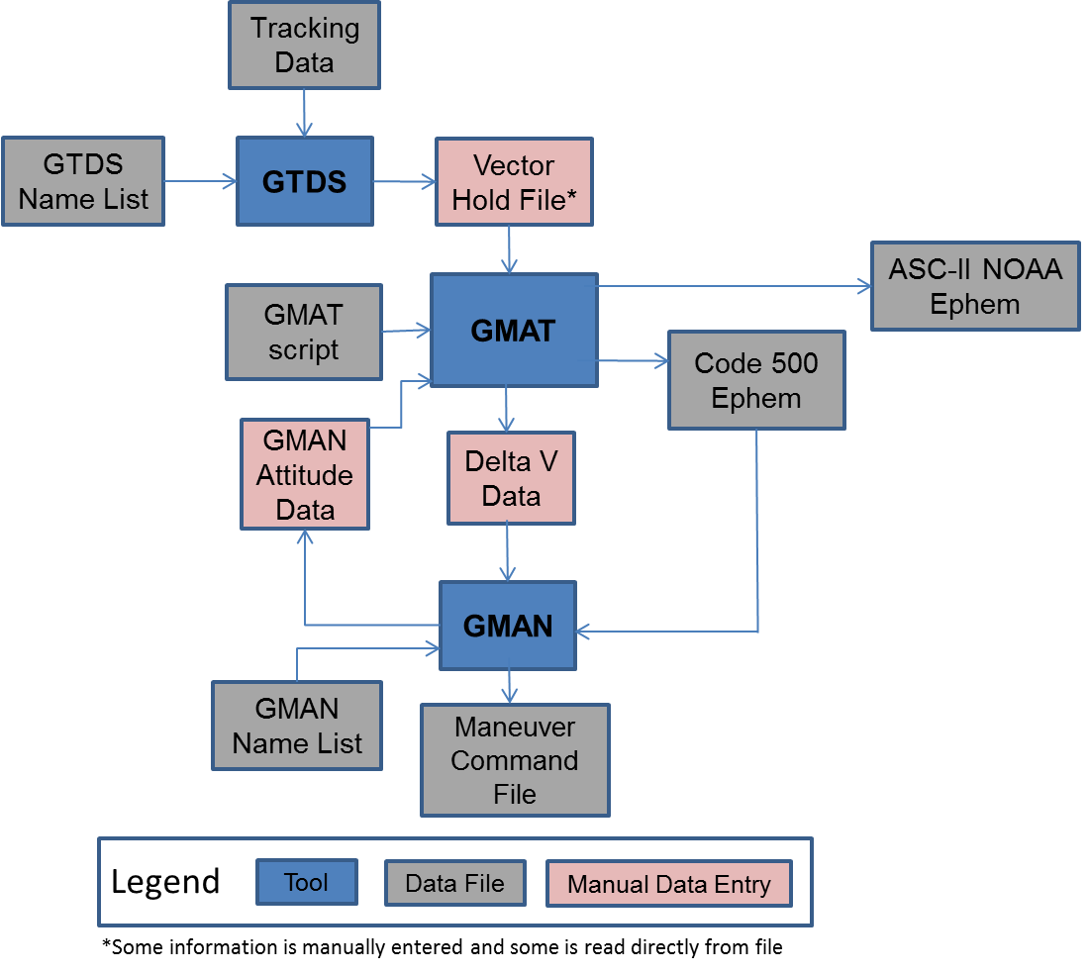

**Figure 5: Tools and Workflow for ACE Maneuver Planning and Support using GMAT**

Similar to FreeFlyer, now GMAT can be used to perform initial impulsive maneuver targeting using an ACE engineering coordinate system. GMAT then generates impulsive delta-v data and a Code 500 ephemeris. This Code 500 ephemeris includes ACE maneuver epoch and corresponding state. Impulsive delta-v data and ACE maneuver epoch from Code 500 ephemeris is read by GMAN. Attitude modeling for ACE is then performed using GMAN. After selection of final attitude parameters has been manually entered into GMAT from GMAN, then final impulsive maneuver is re-targeted in GMAT using a spacecraft-attitude based delta-v coordinate system. Once GMAT performs final impulsive targeting, then GMAT is also used to generate a 28 days long ACE ephemeris. Final finite-burn planning and command generation is performed by GMAN during the maneuver pass and the maneuver command file is generated using GMAN. Finally this maneuver command file is sent to the MOC. The MOC uploads this maneuver command file to the spacecraft.

## Pre-Shadow Operations

Within the FDF, the ACE maneuver operations team uses following two FreeFlyer scripts to fully execute ACE maneuver planning and product generation tasks:

* *ACE_impulsive_###.MissionPlan*
* *ACE_impulsive_NOAA28day_vec###.MissionPlan*

Every week, the latest ACE navigation solution is delivered to the maneuver team through a TVHF file (*vec###.txt*) and both of these scripts are ran using the updated OD state. *ACE_impulsive_###.MissionPlan* is primarily used to:

1. Generate weekly delta-v necessary to predict future station-keeping maneuvers by running latest OD solution from GTDS. This OD solution is found in TVHF file that is ingested into FreeFlyer.
2. After selection of final attitude parameters, final impulsive maneuver is re-targeted in FreeFlyer using a spacecraft attitude coordinate system.

Similarly, FreeFlyer’s *ACE_impulsive_NOAA28day_vec###.MissionPlan* is used to:

1. Generate 28 days long ACE ephemeris for a given TVHF file. This 28 days long ACE ephemeris is the main product from FreeFlyer that is delivered to NOAA.

The design philosophy behind both of these FreeFlyer scripts was intentionally kept very simple. The ACE mission analysts vary input parameters and turn flags on or off as necessary only in the “User Inputs” FreeForm sections of both of these scripts. Once the input parameters and appropriate flags have been set in these FreeFlyer scripts, the mission analysts then run FreeFlyer scripts to analyze ACE maneuvers and product generation.

The script design methodology that we used in GMAT was very similar to that of the FreeFlyer scripts. Just like

FreeFlyer, we used GMAT to write the following two scripts that are utilized to fully support ACE maneuver planning and product generation:

* *ACE_impulsive_###.script*
* *ACE_impulsive_NOAA28day_vec###.script*

Both of these GMAT scripts serve exactly the same purpose as explained above for the FreeFlyer scripts. For a given navigation state from TVHF file, the first GMAT script generates weekly impulsive delta-v necessary for station-keeping and is also used for final maneuver targeting once final attitude parameters have been identified. Similarly, the second GMAT script generates a 28 days long NOAA ephemeris for a given OD solution from a TVHF file. Just like in the FreeFlyer scripts, the mission analysts need to only vary input parameters or turn appropriate flags on or off in the “User Inputs” ScriptEvent section of the GMAT scripts. After setting the input parameters, the mission analysts then run GMAT scripts to analyze ACE maneuvers and generate appropriate products.

Figure 6 explains the basic design methodology for GMAT’s *ACE_impulsive_###.script* through the block diagram on the right and when this script is ran in GMAT, GMAT’s Mission tree is populated as shown on the left. GMAT’s Mission tree on the left shows the “User Inputs” ScriptEvent section of the script. Within the Mission tree, the mission analyst need only amend the input variables found in “User Inputs” ScriptEvent and no other ScriptEvents require any modifications. After all the initializations and setting of the appropriate flags is completed, the station-keeping of the ACE Lissajous mission orbit is performed through the target loop.

Figure 7 explains the basic station-keeping targeting strategy that is utilized in GMAT. In this figure, the ACE mission orbit is drawn in red in the RLP coordinate system. Point 1 on the ACE mission orbit is where an updated navigation solution is provided for the spacecraft via the TVHF file that GTDS generates. ACE then propagates to point 2 starting from point 1. This point 2 corresponds to the attitude re-orientation epoch where perturbations due to spin axis attitude re-orientation maneuver are applied to the ACE mission orbit. After applying the attitude re-orientation maneuver perturbations, ACE then propagates to the maneuver epoch (point 3) where it enters the targeting loop that performs the station-keeping.

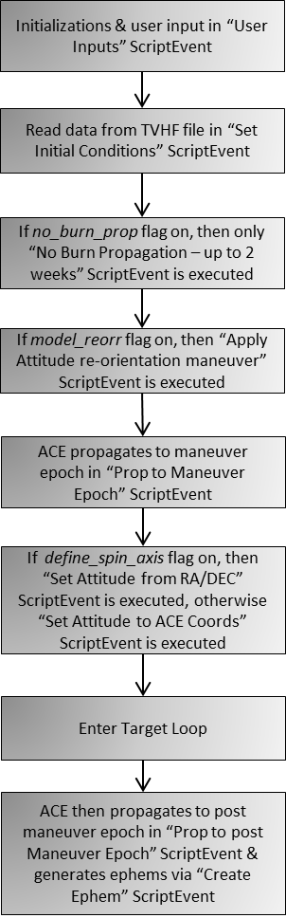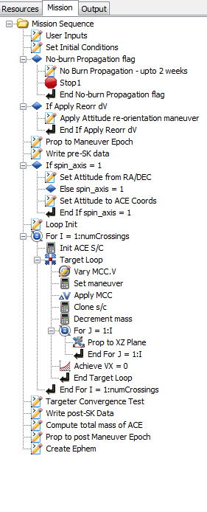

Figure 6: Design methodology for GMAT’s ACE_impulsive_###.script

The ACE station-keeping targeting strategy is a simple one in which single control is varied to meet a single constraint. When ACE is at point 3, GMAT varies the Z component of the delta-V vector in order to make sure that X-component of the spacecraft’s velocity in RLP coordinate frame is 0 at the 4th RLP XZ plane crossing. The XZ plane crossing occurs when spacecraft’s Y component in RLP coordinate system is 0.

Figure 8 explains the basic design methodology for GMAT’s *ACE_impulsive_NOAA28day_vec###.script* through the block diagram on the right and when this script is executed in GMAT, GMAT’s Mission tree is populated as shown on the left. Within the Mission tree, the FDF mission analysts only need to initialize the input variables in the “User Inputs” ScriptEvent and no other ScriptEvents require any modifications.

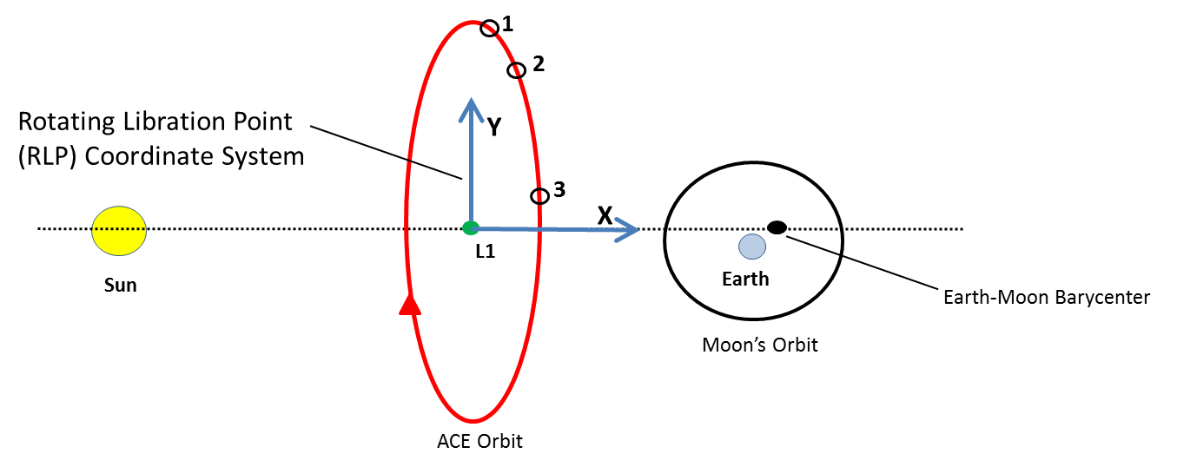

Earth’s motion

**Figure 7: Targeting Strategy for ACE Station-Keeping in GMAT**

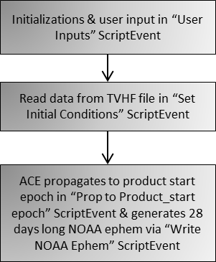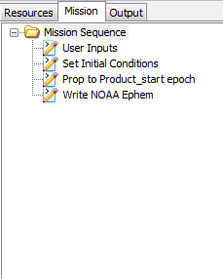

**Figure 8: Design methodology for GMAT’s *ACE_impulsive_NOAA28day_vec###.script***

After completing ACE maneuver planning and product generation scripts using GMAT, it was essential that output from GMAT must be validated against FreeFlyer scripts. The ACE maneuver planning team provided us with 12 TVHF files that contained historical ACE OD solutions from GTDS. After setting same input initialization parameters in both tools, the output from GMAT was compared against FreeFlyer. Out of 12 TVHF files, 8 TVHF files were used to compare impulsive station-keeping maneuver targeting delta-V results between FreeFlyer and GMAT, while 4 TVHF files were used to compare both short and long term propagations. Impulsive station-keeping delta-V, short and long term propagation comparison results between the two tools are discussed in the Results and Analysis section of this paper.

## Results and Analysis

After completing ACE maneuver and product generation scripts in GMAT, we validated the output from GMAT by comparing it against FreeFlyer. Historical navigation solutions from 12 TVHF vector files (*vec###.txt*) were used to test both GMAT’s impulsive targeting (*ACE_impulsive_###.script*) and NOAA product generation (*ACE_impulsive_NOAA28day_vec###.script*) scripts. Specifically, the historical OD solutions from 8 TVHF files were used to compare impulsive delta-V outputs while 4 TVHF files were used to compare short (28 days) and long term (180 days) propagation comparisons.

Table 2 shows impulsive station-keeping (SK) delta-v comparisons between GMAT and FreeFlyer when *model_reorr* & *define_spin_axis* flags were turned off in both tools’ “User Inputs” section of the scripts. Results from GMAT were produced after running *ACE_impulsive_###.script*.

## Table 2: ΔV comparisons between FreeFlyer & GMAT when *model_reorr* & *define_spin_axis* flags are turned off

|  |  |  |  |  |
| --- | --- | --- | --- | --- |
| TVHF  Files Used | Initial State Epoch  [UTCG] | Maneuver Epoch  [UTCG] | GMAT SK ΔV  [cm/sec] | ΔV difference [mm/sec] |
| Vec424.txt | 11 Dec 2012 22:31:25.000 | 15 Jan 2013 17:30:00.000 | 15.01 | 0.024 |
| Vec433.txt | 25 Jan 2013 00:00:00.000 | 15 Apr 2013 16:00:00.000 | 22.75 | 0.017 |
| Vec440.txt | 23 Feb 2013 00:00:00.000 | 19 Mar 2013 16:00:00.000 | 12.53 | 0.018 |
| Vec456.txt | 11 Apr 2013 00:00:00.000 | 25 Jun 2013 19:15:00.000 | 27.98 | 0.016 |

## In Table 2, when *model_reorr* flag is turned off, this means that orbit perturbations due to attitude re-orientation maneuver are not modeled. When *define_spin_axis* flag is turned off, this means that an attitude based delta-v coordination system was not used to target the impulsive maneuver, rather an ACE engineering coordinate system was used to perform initial targeting.Initial state epoch is the epoch that is read from the TVHF file. Maneuver epoch is hard-coded into “User Inputs” ScriptEvent by the user. Starting from the initial epoch, ACE propagates to maneuver epoch and then impulsive station-keeping maneuver is calculated in the target loop. The requirement on station-keeping delta-v differences between GMAT and FreeFlyer stated that the delta-v differences between the two tools have to be less than 0.05 mm/sec. Table 2 shows that for all TVHF files, delta-v differences between the two tools is always less than maximum allowed difference of 0.05 mm/sec. The station-keeping impulsive delta-v output from both tools demonstrated an excellent agreement when compared against each other.

Table 3 shows impulsive SK delta-V comparisons between the two tools when *model_reorr* & *define_spin_axis* flags are turned on in both tools. Since *model_reorr* flag is turned on, GMAT modeled orbit perturbations due to the attitude re-orientation maneuver. Attitude re-orientation maneuver’s epoch, radial, tangential and normal delta-V components are hard-coded into “User Inputs” ScriptEvent. Starting from the initial epoch, ACE first propagates to attitude reorientation epoch, applies the attitude re-orientation maneuver’s delta-V components, then propagates to hard-coded maneuver epoch and enters the target loop. After entering the target loop, GMAT then computes the impulsive delta-V required for ACE station-keeping. Since *define_spin_axis* flag is also turned on, ACE spin axis RA and DEC in Earth-Centered J2000 are hard-coded by the user in “User Inputs” ScriptEvent and impulsive maneuver is computed using the attitude based delta-V coordinate system. Table 3 shows that for all TVHF files, delta-V differences between the two tools is always less than the maximum allowed difference of 0.05 mm/sec. Table 3 further demonstrates that even when all the flags are turned on, there is an excellent agreement between the impulsive delta-V’s that both tools computed.

## Table 3: ΔV comparisons between FreeFlyer & GMAT when *model_reorr* & *define_spin_axis* flags are turned on

|  |  |  |  |  |  |
| --- | --- | --- | --- | --- | --- |
| TVHF  Files Used | Initial State Epoch  [UTCG] | Att. Re-orientation Epoch [UTCG] | Maneuver Epoch  [UTCG] | GMAT SK ΔV  [cm/sec] | ΔV difference [mm/sec] |
| Vec420.txt | 19 Nov 2012 00:00:00.000 | 19 Nov 2012 15:59:50.000 | 19 Nov 2012 17:30:00.000 | 29.65 | 0.021 |
| Vec430.txt | 14 Jan 2013 00:00:00.000 | 15 Jan 2013 16:03:08.000 | 15 Jan 2013 17:30:00.000 | 19.97 | 0.015 |
| Vec450.txt | 01 Apr 2013 00:00:00.000 | 02 Apr 2013 17:49:36.899 | 02 Apr 2013 19:15:00.000 | 19.47 | 0.018 |
| Vec472.txt | 09 Jul 2013 00:00:00.000 | 09 Jul 2013 16:42:37.000 | 09 Jul 2013 17:40:00.000 | 15.30 | 0.012 |

Both short and long-term propagation comparisons were also done between GMAT and FreeFlyer using historical navigation solutions from 4 TVHF files. Table 4 shows both short (28 days) and long-term (180 days) propagation comparisons between the two tools. In GMAT, short and long-term propagations were generated after running *ACE_impulsive_NOAA28day_vec###.script.*

## Table 4: Short and long-term propagation comparisons between GMAT and FreeFlyer

|  |  |  |  |
| --- | --- | --- | --- |
| TVHF  Files Used | Initial State Epoch  [UTCG] | RSS position error after 28 days in EarthMJ2000Eq  [mm] | RSS position error after 180 days in EarthMJ2000Eq  [meters] |
| Vec433.txt | 25 Jan 2013 00:00:00.000 | 0.50 | 2.72 |
| Vec440.txt | 23 Feb 2013 00:00:00.000 | 2.9 | 3.04 |
| Vec450.txt | 01 Apr 2013 00:00:00.000 | 6.1 | 2.62 |
| Vec456.txt | 11 Apr 2013 00:00:00.000 | 1.6 | 4.73 |

## The requirement for propagation comparisons between the two tools stated that after 28 and 180 days of propagation, the RSS position error must be less than 10 millimeters and 5 meters respectively. Table 4 shows that for all TVHF files used, the RSS position error after 28 and 180 days of propagation is way less than 10 mm and 5 meters respectively. This demonstrates that for both short (28 days) & long-term (6 months) propagations, both tools show an excellent agreement between each other. There is only millimeter level disagreement between the two tools after 28 days of propagation and a few meters level difference after 180 days long propagation.

## This comparative analysis of station-keeping impulsive delta-v, short and long-term propagations between the two tools demonstrated the validity of GMAT’s ACE maneuver planning and product generation scripts. GMAT’s output was successfully validated against FreeFlyer’s output and the results further demonstrated that GMAT’s ACE operational scripts can be used to run parallel, non-interfering shadow operations for the ACE mission in the FDF. On 09/23/2013, the FDF’s ACE maneuver planning team used GMAT’s maneuver planning and product generation scripts during a “live” station-keeping maneuver. One sub-team of the maneuver team used FreeFlyer scripts to conduct direct station-keeping maneuver planning for the ACE mission, while another team used GMAT scripts and performed non-interfering, parallel shadow operations. The end results from these non-interfering shadow operations will be discussed later.

## Development of Local Operating Procedures and Test Plans

Currently within the FDF, the ACE maneuver planning team uses a Local Operating Procedures (LOP) document that provides step-by-step instructions to the Mission Analysts (MAs) in how to support ACE maneuver operations using FreeFlyer scripts. This primary governing document for supporting ACE maneuver planning effort using FreeFlyer is called FDSS-LOP-0136 ACE LOPs_v2. This FreeFlyer based LOP document covers various maneuver procedures for the ACE mission. Some key procedures include:

* Procedure for obtaining weekly ACE ΔV for Future Station-keeping Maneuver
* Procedure for ACE Maneuver planning one week prior to the maneuver
* Procedure for ACE Maneuver planning one day prior to maneuver
* Procedure for final SK Maneuver planning (Post-Attitude Maneuver)
* Procedure for generating NOAA 28-day Ephemeris
* Procedure for delivering products via DataViewer

A complete list of all procedures that are based on FreeFlyer for end-to-end ACE maneuver operational support can

be found in the FDSS-LOP-0136 ACE LOPs_v2 document.8

Since the ACE maneuver planning team will be using GMAT scripts to perform parallel maneuver planning and support for the ACE mission, hence it was essential to write a LOP document that references GMAT ACE maneuver planning scripts. We wrote a detailed, 45 pages long LOP document called GMAT-ACE-LOP_v4. This GMAT based LOP document provides detailed instructions to the ACE MAs in how to successfully support ACE maneuver and product generation operations using only GMAT scripts. The GMAT-ACE-LOP_v4 document includes key ACE operational support procedures similar to the ones listed above. The GMAT-ACE-LOP_v4 document went through several internal reviews and test cycles that were performed both by GMAT development and ACE maneuver planning team members. The final version of this document was submitted to the FDF and officially approved by the ACE maneuver planning team. For demonstration purposes, appendix 2 shows only some sample procedures from GMAT-ACE-LOP_v4 document. Please reference the GMAT-ACE-LOP_v4 document for complete and detailed lists of all GMAT based procedures that were written to support ACE maneuver planning effort.9

In order to test all 97 ACE operational support requirements that were levied on GMAT, test plans were written using the standard FDF processes and templates. The FDF uses a test plan and procedures document called Form 15. The ACE maneuver planning requirements are sub-divided into 6 requirements areas: Coordinate System, Force Model, Maneuver Targeting, Orbit Propagation, Product Output and Spacecraft model. The ACE Requirements Traceability Matrix (appendix 1) shows all 97 requirements that are sub-divided into these 6 requirements areas. We wrote detailed test plans documents (Form 15’s) that listed step-by-step procedures of how to test all 97 requirements that fall within the 6 requirements areas. These test plans were delivered to the FDF’s ACE maneuver team. The ACE maneuver team implemented all the test plans and tested to see if GMAT meets all levied requirements. With the FDF, the results after implementation of test plans are tabulated in a document called Form 16’s. The testers issued a results form 16 for each form 15 that contained detailed test plans and procedures. For each test plan, the testers issued either a pass or fail grade. Figure 9 shows Requirements to Test Traceability Matrix (RTTM). The RTTM shows GMAT’s 6 requirements areas, the test plans (Form 15’s) that were written to test the levied requirements and the last column shows the results and status of the test plans. As can be seen in the Status column, a grade of pass was issued for all the requirements that were levied on GMAT. For demonstration purposes, appendix 3 shows only some sample test plans (Form 15’s) that were written to test the levied requirements. A complete list of all Form 15’s that we wrote and delivered to the ACE maneuver team can be found in GMAT-ACE-Test-Plans-Form15s.zip test plans zip file.10

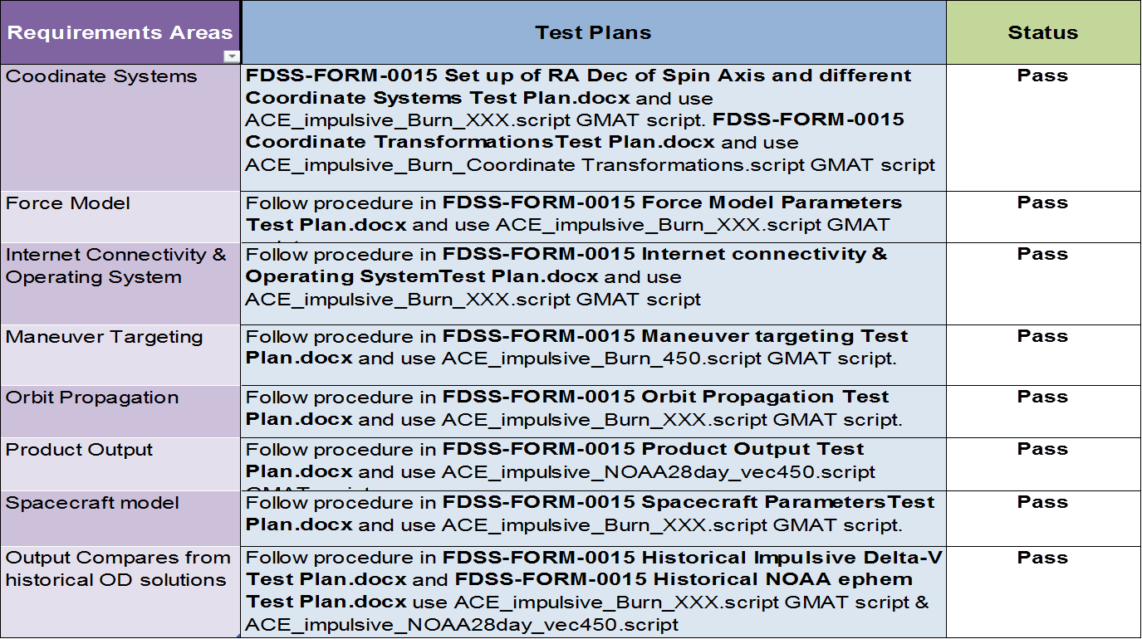

**Figure 9: Requirements to Test Traceability Matrix**

## FDF Training and Shadow Operations

Although GMAT-ACE-LOP_v4 document that we wrote serves as a complete training manual for the ACE maneuver team in how to use GMAT scripts for ACE maneuver planning and product generation support, it was essential to provide hands-on or “GMAT in Action” training to the maneuver team. On September 16, 2013, formal training was given to the FDF maneuver analysts that taught them how to use GMAT’s *ACE_impulsive_###.script* and *ACE_impulsive_NOAA28day_vec###.script* scripts to support end-to-end ACE maneuver operations planning in a true operations environment. After the training, the feedback returned from the maneuver planning team was very positive and encouraging. Since GMAT scripts’ core design philosophy is very similar to the FreeFlyer maneuver operations scripts, the ACE maneuver team found GMAT scripts to be very convenient and easy-to-use. The maneuver planning team is now fully trained to use GMAT scripts in the FDF’s MOR.

On September 23, 2013, the ACE maneuver planning team used GMAT’s maneuver planning and product generation scripts and performed non-interfering, parallel shadow operations during a live ACE station-keeping maneuver session in the FDF’s mission operations room. The maneuver team performed maneuver targeting using GMAT and compared solutions against FreeFlyer. The delivery products from GMAT were used in downstream work flows alongside with products from FreeFlyer to provide end-to-end verification of GMAT solutions and product formats. During this non-interfering parallel shadow operations exercise, we were available in the MOR for back-up technical support but the work was entirely performed by the ACE maneuver team. Table 5 shows the delivery product results from both GMAT and FreeFlyer when latest navigation solution from TVHF file *Vec493.txt* was used. The most recent navigation solution corresponded to the initial epoch of 23 September 2013 00:00:00.000. The impulsive SK delta-V comparisons were done after *model_reorr* & *define_spin_axis* flags were turned on in both tools. Since *model_reorr* flag was turned on, both tools modeled orbit perturbations due to the attitude re-orientation maneuver. Also since *define_spin_axis* flag was turned on, the ACE impulsive maneuver was computed using the most accurate attitude-based delta-V coordinate system. Table 5 also shows propagation comparisons between the two tools after 28 days of propagation. Table 5 demonstrates that there is an excellent agreement when comparing the impulsive delta-V and propagation outputs between the two tools. The non-interfering shadow operations demonstrated that in addition to FreeFlyer, GMAT is also capable of successfully supporting ACE maneuver operations in the FDF.

## Table 5: ΔV and propagation comparisons between FreeFlyer & GMAT when *model_reorr* & *define_spin_axis* flags are turned on

|  |  |  |  |  |
| --- | --- | --- | --- | --- |
| TVHF  File Used | Initial State Epoch  [UTCG] | GMAT SK ΔV  [cm/sec] | ΔV difference [mm/sec] | RSS position error  after 28 days in  EarthMJ2000Eq  [mm] |
| Vec493.txt | 23 Sep 2013 00:00:00.000 | 15.62 | 0.015 | 1.83 |

## Test and Operational Readiness Reviews

On September 10, 2013, the GMAT team presented Test Readiness Review (TRR) to the FDF’s Facility Review Board (FRB). The purpose of the TRR was to demonstrate to the FRB that all tools (including GMAT) and environment were ready to hold non-interfering parallel shadow operations in the FDF. Overview of the GMAT’s maneuver operations scripts and station-keeping delta-V and propagation comparison results from two tools were also presented. We also presented GMAT based LOP document and briefed FRB on the status of the test plans that were being written at the time of the TRR. The FRB was fully satisfied with the status of the test readiness material and GMAT team successfully passed the TRR. The success of the TRR was a major success that gave GMAT the official approval to conduct parallel shadow operations in the FDF during the next planned ACE station-keeping maneuver.

On November 19, 2013, the GMAT team presented Operational Readiness Review (ORR) to the FDF’s FRB. The purpose of ORR was to present the findings of the non-interfering parallel shadow operations that were held in the FDF on September 23, 2013. Additionally, the GMAT team presented the results after the test plans were implemented by the ACE maneuver team to verify all the maneuver support requirements levied on GMAT. The GMAT team successfully passed the ORR and the FRB has officially deemed GMAT operationally ready and certified to plan for and support ACE maneuver operations in the FDF.

# Conclusion

This paper documented at a high level major operational certification milestones and entire engineering lifecycle that GMAT went through in order to be deemed an operationally certified tool that is ready to support ACE maneuver operations in the FDF. Table 6 identifies and summarizes major milestones and their current status in the operational certification process.

**Table 6: Operational Certification Milestones**

|  |  |  |
| --- | --- | --- |
| Milestone | Status | Summary |
| Requirements gathering | Completed | Coordinated completion of all ACE maneuver support requirements levied on GMAT by working with ACE maneuver team |
| System Requirements Review | Completed | Final review of ACE maneuver support requirements was conducted by FDF’s Facility Review Board (FRB) |
| Gaps Analysis | Completed | Analyzed ACE requirements to determine areas where GMAT does not meet requirements and requires development of new features |
| Development of new features | Completed | GMAT software Developers developed new features identified by the Gaps analysis |
| Pre-Shadow Operations | Completed | Wrote GMAT ACE scripts. A vigorous analysis involving comparison between GMAT & FreeFlyer’s propagation and maneuver targeting results was conducted. |
| Local Operating Procedures & Test Plans Development | Completed | * Wrote detailed test procedures document (ACE Local Operating Procedures (LOP)) that provides instructions to FDF’s Mission Analysts for supporting ACE maneuver operations. * Wrote detailed Test Plans documents (Form 15s) that covered all requirements for ACE operational maneuver planning. Test Plans were documented using standard FDF processes and templates. |
| Test Procedures & Plans Review | Completed | FDF’s ACE maneuver team reviewed and approved test procedures and test plans documents |
| Test Readiness Review | Completed | On 09/10/13, we gathered test readiness material and presented a successful TRR to FDF’s FRB |
| FDF Training | Completed | Provided training to ACE maneuver planning team which involved instructions on how to use GMAT’s ACE impulsive maneuver targeting and product generation scripts. |
| Shadow Operations | Completed | On 09/23/2013, FDF’s ACE maneuver planning team used GMAT in parallel shadow operations. ACE maneuver team performed maneuver targeting using GMAT and compared solutions to FreeFlyer. Delivery products from GMAT were used in downstream work flows alongside products from FreeFlyer to provide end-to-end verification of GMAT solutions and product formats. I was available for technical support during shadow operations but work was performed by ACE maneuver team. |
| Operational Readiness Review | Completed | On 11/19/2013, we presented ORR to the FRB and presented findings of shadow operations and results after test plans were implemented by the ACE maneuver team. GMAT successfully passed ORR and FRB has granted GMAT full operational certification status to support ACE mission operations in the FDF |

The primary focus of this effort was to demonstrate that GMAT is a mature, flight quality system that has been operationally certified to support real-time spacecraft mission operations. The work that we presented here is unique because prior to this effort, GMAT had never gone through an operational certification cycle in order to be deemed qualified to support mission operations in the FDF. Now in addition to being certified for ACE operations, this work has laid core groundwork for GMAT to target operational certification for other present and future Goddard missions. GMAT is installed in FDF’s mission operations room and now in addition to FreeFlyer, GMAT can be used as the primary maneuver planning tool to support ACE mission operations.

**Appendix**

# Appendix 1: ACE Requirements Traceability Matrix



# 

# 

# 

**Appendix 2: Sample Procedures copied from GMAT-ACE-LOP_v4 document**

**5.3 ACE Maneuver Planning**

The information below details ACE maneuver planning including preliminary and final planning, maneuver execution, and post-maneuver activities. More detailed procedures are referenced where necessary, refer to them as needed.

**5.3.1 One Week Prior to Maneuver**

1. Retarget ΔV using the weekly ACE ΔV procedure in section 5.1 if necessary.
2. Once the SK maneuver date is selected, inform Operations Analysts (OAs) within FDF so information can be added to FDF Activity Schedule.
3. Send brief on SK maneuver to FOT and Orbit personnel.
4. GSFC-DL-MMOC-FOT@mail.nasa.gov, robert.j.sodano@nasa.gov, rivers.lamb@nasa.gov, edward.m.nace@nasa.gov,

gsfc-fdf-maneuver@lists.nasa.gov

* + 1. **One Day Prior to Maneuver**

1. Check for a new OD state file (*vec###)*, move to the appropriate folder.
2. Copy and rename the previous **ACE_impulsive_###.script** into a new vector folder.
3. Create a new **SK-##** folder with the current Station-keeping maneuver number.
4. An email with a GMAN .lst file will be sent with pre-attitude maneuver information.
5. Under Resources tree, look for Interfaces folder and open resource called “tvhf”.
6. Under Filename field, search for the appropriate OD vector file …*vec###.txt* file by clicking on the Browse button and click OK
7. Edit all instances of *vec###* & *SK##* to the current vector number from OD and to the current station keeping number. If needed, refer to procedure in section 5.1 that explains how to edit GMAT’s Resource objects (listed under Output folder) with updated *vec###* & *SK##* in Resources tree. After updating all subscribers listed under the Output folder, don’t forget to click on Save button. This ensures that changes you made are saved and GUI and Script modes are synchronized.
8. Click on the Mission tab and open the “User Inputs” ScriptEvent. Implement the following steps:
   1. Make sure that *use_tvhf* is set to 1
   2. Make sure that *no_burn_prop* is set to 0
   3. For preliminary maneuver targeting, the *model_reorr* variable should be set to 1 (turned on)
   4. Update ­*reorr_epoch, reorr_radial, reorr_tangential, reorr_normal,* and *reorr_fuel_used* with values from the .lst file
   5. Double check that the *maneuver_epoch* is set to the correct data and time
   6. *maneuver_seed* can be initially set to 0, or if retargeting from a previous week, left as is
   7. *target_crossing* can be set to 4. GMAT’s script should converge just fine if set to 4
   8. *tank_mass* should be set to the value found in the .lst file
   9. *sk_fuel_used*: Most recent value should be entered here
   10. *define_spin_axis* should be set 1 (turned on)
   11. *Z_RA* and *Z_Dec* should be updated from same .lst file
   12. *postmaneuver_epoch* should be set to nearest even hour after the epoch that is defined under *maneuver_epoch*
   13. *NumDays_after_maneuver* is by default set to 180 days. User can set it to any desired value
9. You can also consult Table 3 in Appendix B in order to get a summary of input variables or flags that need to be turned on/off in order to successfully run section 5.3.2 of this LOP.
10. Click OK to close “User Inputs” ScriptEvent. Click on Save button (located below the Edit tab). Clicking on Save button ensures that your changes are saved and it also makes certain that GMAT’s GUI and Script modes are both synchronized.
11. Click on Run button and GMAT’s targeter should converge. After mission run has completed, you can access appropriate report and ephemeris files to obtain any pertinent data. For example, “skSummaryReport” in Output tree contains data like ACE’s state at SK start, impulsive SK delta-v components or post burn state.
12. Now access ΔV vector components from GMAT and convert to ft/s. (ΔV vector components can be found in “skSummaryReport” report file under “Impulsive SK Delta-v Components” section of the report).
13. Using the procedure “Generating ACE Maneuver plan in GMAN” defined in section 5.4, create a preliminary maneuver plan. Details on required inputs are below.
14. New ephemeris based on latest OD (span must include maneuver epoch). This can be generated using the same **ACE_impulsive_###.script**. Open “User Inputs” ScriptEvent, set *no_burn_prop* to 1 (setting this flag to 1 makes sure that **ACE_impulsive_###.script** will now only generate two week long no burn propagation). *NumDays* by default is set to 14 (two weeks). Click OK to close “User Inputs” ScriptEvent. Click on Save button in order to ensure that GMAT’s GUI and Script modes are synchronized and changes that were made are saved. Now run GMAT by hitting the Run button to simulate the two weeks long no burn propagation.
15. After run, GMAT’s two weeks long no-burn propagation report file (“ephem_GMAT_nb”) can be viewed in Output tree or this file can be found in the path where this modified report was saved into. Also code 500 (PC version) ephemeris file for two weeks long no-burn propagation that was generated using the “ephem_code500_pc_nb” EphemerisFile object can be found in the path where it was saved into.
16. The axial thrusters used for the burn depend on the direction of the delta-v. 1A and 2A are for anti-Sunward, 3A and 4A for sunward.
17. Fuel tank weights (lbm), pressures (psi), and temperatures (°C) are from the last post-maneuver **sk-##p_calib-01.lst** file.
18. Spin rate (rpm) and spin axis RA / DEC (deg) are from the pre-attitude .lst file
19. DSN Ground Tracking Station that will be used during the maneuver. See section 5.8.2 for details on determining the DSN station.
20. Thrust and Isp Calibration factors which are determined from previous maneuver calibration that used the same set of thrusters, same/similar delta-v, or based on analysis. Isp Calibration is nominally the same as the thrust calibration factors.
21. Run and QA GMAN output based on the procedure in section 5.4
    * 1. **Final Orbit SK Maneuver Planning (Post-Attitude Maneuver)**
22. Use the **ACE_impulsive_###.script** to generate the final maneuver plan (Refer to procedure in section 5.1 if needed).
23. Place latest attitude reorientation ΔV (RTN) values received from the FOT into the *Attitude Reorientation* section of the “User Inputs” ScriptEvent. This will be given via a phone call.
24. Input the updated *tank_mass* into the *Maneuver* section of “User Inputs” ScriptEvent.
25. Calculate and input the midpoint of the reorientation burn epoch in *reorr_epoch* into *Attitude Reorientation* section of the “User Inputs” ScriptEvent.
26. Input actual spin axis RA/DEC (from FOT) into *Z_RA* and *Z_Dec* into *Maneuver* section of “User Inputs” ScriptEvent.
27. Click OK to close “User Inputs” ScriptEvent and click on Save button. Now run GMAT by clicking on Run button. Targeter should converge after few iterations.
28. Now obtain new ΔV for SK burn by opening “skSummaryReport” report file in Output tree. This report file can also be accessed from the path that the user selected to save this report file into.
29. Open the final GMAN .lst file **sk-##p_final-01.lst** (refer to section 5.4 if needed).
30. Place new ΔV magnitude (converted from km/sec to ft/sec) into GMAN namelist.
31. Input latest post-reorientation spin axis RA/DEC/SPIN updates (from FOT)
32. Input latest fuel tank PRESSURES/TEMPS/FUEL WEIGHTS plus JET (thruster) TEMPS (all values from FOT).
33. Run GMAN via the command prompt and inspect/QA .lst file and command sheet file.
34. Transmit Command Sheet file to FOT via the DataViewer SendRequest function (see Section 5.8). File placed on *stewart* in directory ACE/MOC/Maneuver as: **ACE_SkCommand_yyyymmdd.nn.cmd**
35. Check that DSN 2-way tracking data is arriving including Doppler (see Section 5.8.2)
36. Calculate predicted drop in spin rate by taking the previous maneuver’s drop ((Δω) (i.e., maneuver that used the same thrusters) and multiplying it by the ratio of the current burn duration, ΔT, to the previous maneuver’s ΔT to get the estimated drop for the current maneuver. The equation for this is:

Drop in spin rate = previous man. Δω * (current man. ΔT / previous man. ΔT)

1. Call FOT at 6-4712 or 6-4927 and let them know the expected drop in the spin rate due to the Station-keeping maneuver.

**5.6 Generating NOAA 28-day Ephemeris**

The purpose of this part of these Local Operating Procedures (LOP) is to generate a NOAA 28-day ephemeris using GMAT.

Table 4 in Appendix B lists general description of all input variables and their usage. These input variables are set in the “User Inputs” ScriptEvent found in GMAT’s **ACE_impulsive_NOAA28day_vec###.script**. After loading the script in GMAT, within the Mission tree, the user needs to only amend the input variables found in “User Inputs” ScriptEvent and no other ScriptEvents should require any modifications.

Table 5 in Appendix B lists how the input variables in “User Inputs” ScriptEvent should be set up in order to successfully run section 5.6.1 of this LOP.

**5.6.1 Procedure**

This procedure should be performed on a cycle of approximately once every 14 days and immediately after every station-keeping maneuver.

1. An email with the latest vector should have been received from Orbit Group. Note the vector number, retrieve from the Unix side directory **missions/ace/products/tvhf** and place on Windows-side directory in **R:\FDDFDOA\PROJECTS\ACE\MNVR\EPHEMS\TVHF**. It should have the naming convention of **vec*###*.txt**, where ***###*** is the vector number.
2. Find the previous **ACE_impulsive_NOAA28day_vec###.script**. Copy and rename to the current vector number. Open the script in GMAT and click on “Save,Sync” button to populate GMAT’s Resources and Mission trees.
3. Under the Resources tree, look for Interfaces folder and open resource called “tvhf”.
   1. Under Filename field, search for the appropriate OD vector file …*vec###.txt* file and click OK to close the FileInterface - tvhf resource.
4. Under Resources tree, look for Output folder and open “skSummaryReport” ReportFile object. “skSummaryReport” is a modified report file which contains various data fields like spacecraft’s state at SK start, impulsive SK Delta-V components.
   1. Under Filename field, browse for the appropriate path where you would like to save this report file. Name this report file with the name of your choice (default name is …*SK_impulsive_GMAT_More.report).* Note: After GMAT is run, the report file can be opened from the GMAT Output tree, or by opening the file from the file system at the path specified. Click OK to close this resource.
5. Under Resources tree, look for Output folder and open “noaaReport” ReportFile object. “noaaReport” is a modified ephemeris report file which reports ACE’s epoch in UTCModJulian, state vector and acceleration vector components at intervals of every 3600 seconds for the span of 28 days. This modified ephemeris is delivered to NOAA and starts from epoch defined in *product_start* variable(*product_start* variable is defined by the user in “User Inputs” ScriptEvent located in Mission tree).
   1. Under Filename field, select the appropriate path where you would like to save this modified ephemeris report file. Naming convention of this ephemeris file is*…\ACE_EPHPred_YYYYMMDD.asc,* where YYYY corresponds to the 4-digit year, MM corresponds to the 2-digit month, DD corresponds to the 2-digit day of month. Click OK to close this panel. Note: After GMAT is run, the report file can be opened from the GMAT Output tree, or by opening the file from the file system at the path specified.
   2. Since we have modified the GUI, we should save these changes. Click on Save button (located below the Edit tab). Clicking on Save button ensures that your changes are saved and also makes certain that GMAT’s GUI and Script modes are both synchronized.
6. Now go to Mission tree and open the “User Inputs” ScriptEvent and update the following variables:
7. *use_tvhf* should be set to 1
8. *product_start* should be set to today’s date
9. Update *tank_mass* to current value from the attitude reorientation email
10. If there is no maneuver within the next 28 days, *include_maneuver* should be set to 0, otherwise set to 1 and update the *maneuver_epoch* to the chosen date
11. If *include_maneuver* is set to 1, then enter modeled dV in *maneuver_seed*
12. *define_spin_axis* should be set to 0 or 1
13. If *define_spin_axis* is set to 1, then enter RA and Dec for *Z_RA* and *Z_Dec*
14. You can also consult Table 5 in Appendix B in order to get a summary of input variables or flags that need to be turned on/off in order to successfully run section 5.6.1 of this LOP.
15. Click OK to close the “User Inputs” ScriptEvent. Click on Save button to save the changes that have been made. This also ensures that GUI and Script modes are synchronized.
16. Run this script by clicking on the Run button. When run is complete, “sksummaryReport” and “noaaReport” can be viewed in Output tree or you can open these reports from the path where these reports were saved in.

**Appendix 3: Test Plans (Form 15’s) that cover Product Output (PO) requirements Area**

|  |  |
| --- | --- |
| **Module/Software:** | **ACE Impulsive Maneuver Planning** |
| **Version:** |  |
| **Mission (or N/A):** | **Task 9, ACE Maneuver** |
| **Date:** | **09/04/13** |
| **Testers:** |  |

|  |
| --- |
| **Test Description** |
| **Demonstrate NOAA ephem output, code 500 ephems, visualizations and maneuver summary report:** Demonstrate that GMAT can output NOAA ephem, Code 500 ephems and maneuver summary report after each run. |

|  |  |
| --- | --- |
| **Reference document** | **document location** |
|  |  |

|  |
| --- |
| **SYSTEM CONFIGURATION** This should be a brief description of the test setup environment (system name or other information that can be used to identify hardware, network, software, servers and other system configuration information) required for valid test execution |
| Workstation with access to FDFNet and GMAT R2013b, using ACE_impulsive_NOAA28day_vec450.script & ACE_impulsive_Burn_XXX.script |

|  |
| --- |
| **FunctionalitiES Tested/requirmentS** |
| This test plan is testing following requirements from ACE requirements document (FDSS-TO9 Maneuver Task Requirements Traceability Matrix - ACE only.xlsx) :  **PO01:** The ground system shall generate a NOAA Ephemeris, as delineated in Appendix A.  **PO 02:** The ground system shall support generating ephemeris files starting with a user-defined epoch, which may differ from the maneuver epoch.  **PO 03:** The ground system shall be able to generate an ephemeris in the Unix version of the GSFC Code 500 binary format.  **PO 04:** The ground system shall be able to generate an ephemeris in the PC version of the GSFC Code 500 binary format.  **PO 05:** The ground system must be able to display a visualization of the spacecraft's orbit during propagation in the XY RLP frame.  **PO 06:** The ground system must be able to display visualizations during propagation (i.e., the ground system must not wait until runtime completion to display outputs).  **PO 07:** The ground system shall generate a maneuver summary report as delineated in Appendix B. |

|  |  |
| --- | --- |
| **Input File Description** | **Input File** |
| TVHF file is needed to successfully load GMAT script without any errors. | Vec450.txt |

|  |  |  |
| --- | --- | --- |
| **Parameter File** | **Parameter** | **Value** |
|  |  |  |

**Test 1: Test PO01 requirement. Demonstrate that GMAT can generate NOAA ephemeris:**

|  |
| --- |
| **Procedure** |
| 1. Make sure GMAT is closed. Before starting GMAT, make sure that GMAT’s “tai-utc.dat” leap second file is configured to use 34 leap seconds. Once the tester has confirmed this, then go to step 2. 2. Place vec450.txt TVHF file in the bin folder (bin folder is located in GMAT’s directory). In GMAT, Default location for TVHF files is the bin folder. 3. Open GMAT and load script ACE_impulsive_NOAA28day_vec450.script. Within the Resources tree, this script will show under Scripts folder. Open this script and click “Save/Sync.” This populates GMAT’s Resources and Mission tree. 4. Go to Mission tree and open “User Inputs” ScriptEvent. Under *Input state* section, notice *use_tvhf* is set to 1 by default. This means GMAT will read spacecraft’s initial epoch, state& Cr from vec450.txt. All of the correct epochs and other parameters that correspond to vec450.txt vector file have already been entered into variables that are listed under *Product Start, Fuel Remaining* & *Maneuver* sections. Correct product start epoch has been already entered. Under *Maneuver* section, notice that *include_maneuver* and *define_spin_axis* flags are turned on and correct maneuver epoch has already been entered.   These input parameters will help us generate a 28 days long NOAA ephemeris which is based off of vec450.txt. Since “User Inputs” ScriptEvent is already configured with appropriate parameters, we are ready to run GMAT. Click OK to close “User Inputs” ScriptEvent & click on Run button (located below and slightly to the right of Help tab).  As GMAT is running, note two graphics windows and single XY Plot window. EarthSunMoonView graphics window shows ACE in RLP coordinate frame, EarthSunView graphics window shows ACE in earth-sun-rotating coordinate system, XY plot on bottom center shows ACE in XY RLP frame.   1. After run, go to Output tree and open “noaaReport” report file. This is the report file that generates 28 days long NOAA ephemeris as delineated by requirements listed in Appendix A. This 28 days long NOAA report reports Mod. Julian date, state vector, acceleration components at 1-hour time steps.   This “noaaReport” was generated after creating and configuring noaaReport ReportFile object in lines 408 through 420 of the script. This “noaaReport” object can also be seen in Resources tree under the Output folder. Now go to Output folder (located in GMAT’s directory). In GMAT, Output folder is where all the reports and ephemeris files are saved by default. Notice that a NOAA file by the name of "ACE_EPHPred_20130402.asc" is created.  You can either open “noaaReport” in GMAT’s Output tree or open "ACE_EPHPred_20130402.asc" in Notepad++ or any other text editor to study it in detail. Study the contents of this NOAA ephemeris and tester can validate it against FreeFlyer’s 28 days long NOAA ephemeris. GMAT’s "ACE_EPHPred_20130402.asc" meets PO01 requirement as well as all of the requirements delineated in Appendix A (i.e. NE1 through NE10 requirements).     1. The user can completely close GMAT by going to File>Exit. |
| **expected results** |
| GMAT will demonstrate successful creation of 28 days long NOAA ephemeris, hence satisfying PO01 and NE01 through NE11 REQ-IDs. |
| **acceptance criteria** |
| Validate expected results by running FreeFlyer with same input parameters used in “User Inputs” ScriptEvent. |

**Test 2: Test PO02 through PO07 requirements. Demonstrate code 500 ephem generation, visualization and maneuver summary report:**

|  |
| --- |
| **Procedure** |
| 1. Make sure GMAT is closed. Before starting GMAT, make sure that GMAT’s “tai-utc.dat” leap second file is configured to use 34 leap seconds. Once the tester has confirmed this, then go to step 2. 2. Make sure vec450.txt TVHF file in the bin folder (bin folder is located in GMAT’s directory). In GMAT, Default location for TVHF files is the bin folder. 3. Open GMAT and load script ACE_impulsive_Burn_XXX.script. Within the Resources tree, this script will show under Scripts folder. Open this script and click “Save/Sync.” This populates GMAT’s Resources and Mission tree. 4. Go to Mission tree and open “User Inputs” ScriptEvent. Under *Input state* section, notice *use_tvhf* is set to 1 by default. This means GMAT will read spacecraft’s initial epoch, state & Cr from vec450.txt. All of the correct epochs and other parameters that correspond to vec450.txt vector file have already been entered into variables that are listed under *Attitude Reorientation, Maneuver* & *Post maneuver epoch* sections.   Notice that *model_reorr* flag is turned on, attitude reorientation epoch has already been entered into *reorr_epoch,* radial, tangential, normal components have already been entered into *reorr_radial, reorr_tangential, reorr_normal.* Also appropriate fuel has also been entered into *reorr_fuel_used*.  Correct maneuver epoch has been entered for *maneuver_epoch, target_crossing* is set to 4, correct tank mass is entered for *tank_mass,* appropriate fuel used has already been added for *sk_fuel_used.* Notice that *define_spin_axis* flag is turned on and appropriate RA and DEC values have already been added to *Z_RA* and *Z_Dec*.  Under *Post maneuver epoch* section, *postmaneuver_epoch* is where user enters a user-defined epoch, which differs from the maneuver epoch. After targeter converges, spacecraft propagates to user-defined post maneuver epoch and ephemeris files are generated starting from the user-defined epoch defined in *postmaneuver_*epoch. This satisfies requirement listed under PO02 REQ-ID. Code 500 ephemeris (both PC and UNIX versions) and modified report file “GMATephem” are generated starting from the post maneuver epoch that the user defines in *postmaneuver_epoch*. A correct post maneuver epoch (which corresponds to vec450.txt vector file) has already been defined for tester’s convenience.  *NumDays_after_maneuver* is where user defines the total # of days for which code 500 ephemeris and “GMATephem” report files will be generated for. By default, *NumDays_after_maneuver* is set to 180 days, which roughly equals to ACE’s full orbit revolution. This variable can be modified at user’s choice.   1. Since “User Inputs” ScriptEvent is already configured with appropriate parameters, we are ready to run GMAT. Click OK to close “User Inputs” ScriptEvent & click on Run button (located below and slightly to the right of Help tab).   As GMAT is running, user will see two graphics windows and two XY Plot windows. “EarthSunMoonView” graphics window shows spacecraft in RLP coordinate frame, “EarthSunView” graphics window shows ACE in earth-sun-rotating coordinate system & XY plot on bottom right shows ACE in XY RLP frame as the targeter runs and converges for up to 4 RLP XZ plane crossings. XY plot on bottom left shows spacecraft in XY RLP frame propagating forward starting from post maneuver epoch which was defined in *postmaneuver_epoch*. Spacecraft in bottom left RLP XY plot propagates for # of days which was defined in *NumDays_after_maneuver* variable (in this case 180 days). These four graphics windows satisfy the XY RLP frame visualization & real-time updates requirements which are defined by PO05 and PO06 REQ-IDs.  Note: While GMAT is running, GMAT’s Message Window shows all current targeter iterations and converged dV solutions for up to 4 XZ plane crossings.   1. After GMAT run is completed, go to Output tree and open “GMATephem” report file. Similar to FreeFlyer, starting from the post maneuver epoch defined in *postmaneuver_epoch,* this report file reports UTC epoch, state vector, total mass and TAI Julian epoch at time steps of 3000 seconds. “GMATephem” report file is generated for # of days defined in *NumDays_after_maneuver*. “GMATephem” object was created in lines 463 through 475 of the script. “GMATephem” object can also be found in GMAT’s Resources tree under the Output folder.   Now go to GMAT’s directory and open Output folder (by default, after each run, GMAT places all report and ephemeris files in its Output folder). In this Output folder, user will see two code 500 ephemeris files (in our case: ACE_vec450_PC.eph & ACE_vec450_Unix.eph). These code 500 ephemeris files are generated starting from user-defined epoch in *postmaneuver_epoch* and is generated for # of days defined in *NumDays_after_maneuver*. Similar to FreeFlyer, GMAT generates code 500 ephems at fixed time steps of 600 seconds. “CODE500PC” and “CODE500UNIX” objects (shown in the Resources tree) were created starting from lines 477 through 511 of the script). This satisfies the requirements defined under PO03 & PO04 REQ-IDs.  Now go back to GMAT’s Output tree and open “skSummaryReport” report file. “skSummaryReport” is the maneuver summary report that GMAT generates as delineated in Appendix B. Now go to Output folder (located in GMAT’s directory). Inside the Output folder, you’ll find maneuver summary report titled “SK66_impulsive_GMAT_More.report”. “skSummaryReport” ReportFile object was created in lines 449 through 461 of the script. “skSummaryReport” object can also be found in GMAT’s Resources tree under the Output folder.  Study the contents of this maneuver summary report and tester can validate it against FreeFlyer’s maneuver summary report. GMAT’s maneuver summary report meets PO07 requirement as well as all of the requirements delineated in Appendix B (i.e. MR1 through MR06 requirements).   1. The user can close GMAT now by going to File>Exit. |
| **expected results** |
| GMAT will demonstrate that it is able to generate code 500 ephemeris, can display real-time visualizations and generates a maneuver summary report. |
| **acceptance criteria** |
| Validate expected results by running FreeFlyer with same input parameters used in “User Inputs” ScriptEvent. |

|  |
| --- |
| **TEST PLAN REVIEWED AND APPROVED BY** (print name) |
|  |

See FDSS-LOP-0004 *Flight Dynamics Facility (FDF) Local Operating Procedure (LOP) for Operations Test Methodology* for instructions on completing this form.

**Acknowledgments**

The authors would like to acknowledge the assistance of entire GMAT team in particular Linda Jun, Darrel Conway, Wendy Shoan, Joel Parker, Steve Cooley and Thomas Grubb. R. Qureshi would like to thank FDF ACE maneuver planning team for their help throughout the operational certification process. He would also like to acknowledge Qumerunnisa Qureshi for her encouragement and support.

**References**

1 Roberts, C.R., “Long Term Missions at the Sun-Earth Libration Point L1: ACE, SOHO, and WIND,” *AAS/AIAA*

*Astrodynamics Specialist Conference, Girdwood, Alaska,* August 2011.

2 Roberts, C.R., "Long Duration Lissajous Orbit Control for the ACE Sun-Earth L1 Libration Point Mission." *Advances*

*in the Astronautical Sciences,* Vol. 108, Part 2, 2001, pp. 1447–1464.

3Dunham, D.W., and Roberts, C.R., "Stationkeeping Techniques for Libration Point Satellites." *The Journal of the*

*Astronautical Sciences* , Vol. 49, No. 1, January-March 2001, pp. 127–144.

4The GMAT Development Team, “General Mission Analysis Tool (GMAT) User Guide R2013b,” NASA GSFC.

5Hughes, S.P., “General Mission Analysis Tool (GMAT) Software Management Plan/Product Plan,” Version 1, October

2013.

6Flight Dynamics Facility, Goddard Space Flight Center, “FDSS-TO9 Maneuver Task Requirements Traceability Matrix –

ACE only.xlsx,” July 2013.

7GMAT, General Mission Analysis Tool, Software Package, Ver. R2013b, NASA Goddard Space Flight

Center, Greenbelt, MD, 2013.

8FreeFlyer based ACE Local Operating Procedures document, FDSS-LOP-0136 ACE LOPs_V2, Flight Dynamics Facility, NASA Goddard Space Flight Center, Greenbelt, MD, 2013.

9GMAT based ACE Local Operating Procedures document, GMAT-ACE-LOP_v4, Flight Dynamics Facility,

NASA Goddard Space Flight Center, Greenbelt, MD, 2013.

10GMAT Test Plans and Procedures Form 15’s document, GMAT-ACE-Test-Plans-Form15s.zip, Flight

Dynamics Facility, NASA Goddard Space Flight Center, Greenbelt, MD, 2013.

1. Aerospace Engineer, Navigation and Mission Design Branch
2. Aerospace Engineer, Navigation and Mission Design Branch